

The 2026
International
Jaguar Festival Roars into Pittsburgh
Register at:
pvgp.org/car-show-overview/jaguar2026

July 16-18, 2026
​Jaguar Named Marque of the Year
at Pittsburgh Vintage Grand Prix


If there has ever been a moment when Jaguar owners, enthusiasts, and historians should circle a date on the calendar in bold red ink, this is it.
​

From July 16–18, 2026, the International Jaguar Festival (IJF) will take place in Pittsburgh, Pennsylvania—embedded within the world-renowned Pittsburgh Vintage Grand Prix (PVGP) Motorsports Festival, where Jaguar will be celebrated as Marque of the Year. Legendary designer Ian Callum will serve as Grand Marshal. In the words of automotive authority Ramsey Potts: “You need to be here.”
​

An IJF Like No Other
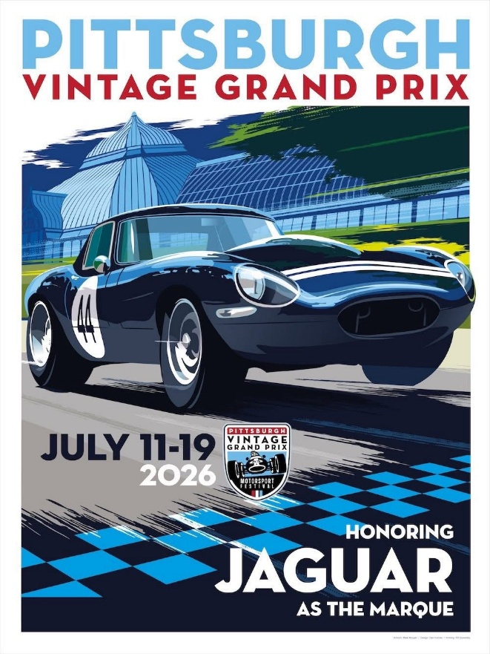
The 2026 IJF is not merely being hosted alongside the Pittsburgh Vintage Grand Prix—it is fully woven into it. From Thursday through Saturday, Jaguar owners will enjoy a front-row seat to one of the world’s most extraordinary motorsports festivals.​

The PVGP is the only vintage street race in the United States and ranks among the most significant historic racing events in the world. In 2025, it was again named a finalist for Motorsport Event of the Year by the International Historic Motoring Awards, alongside the Silverstone Festival, Le Mans Classic, and the Rolex Monterey Motorsports Reunion. That global recognition speaks volumes.​

The PVGP spans multiple weeks and includes vintage circuit racing, a hill climb, internationally significant car shows, galas, rallies, parades, and social events—all benefiting autism charities. Every dollar raised through IJF participation supports these causes, making this a celebration with a purpose.

Host Hotel: Comfort, Access, and Space
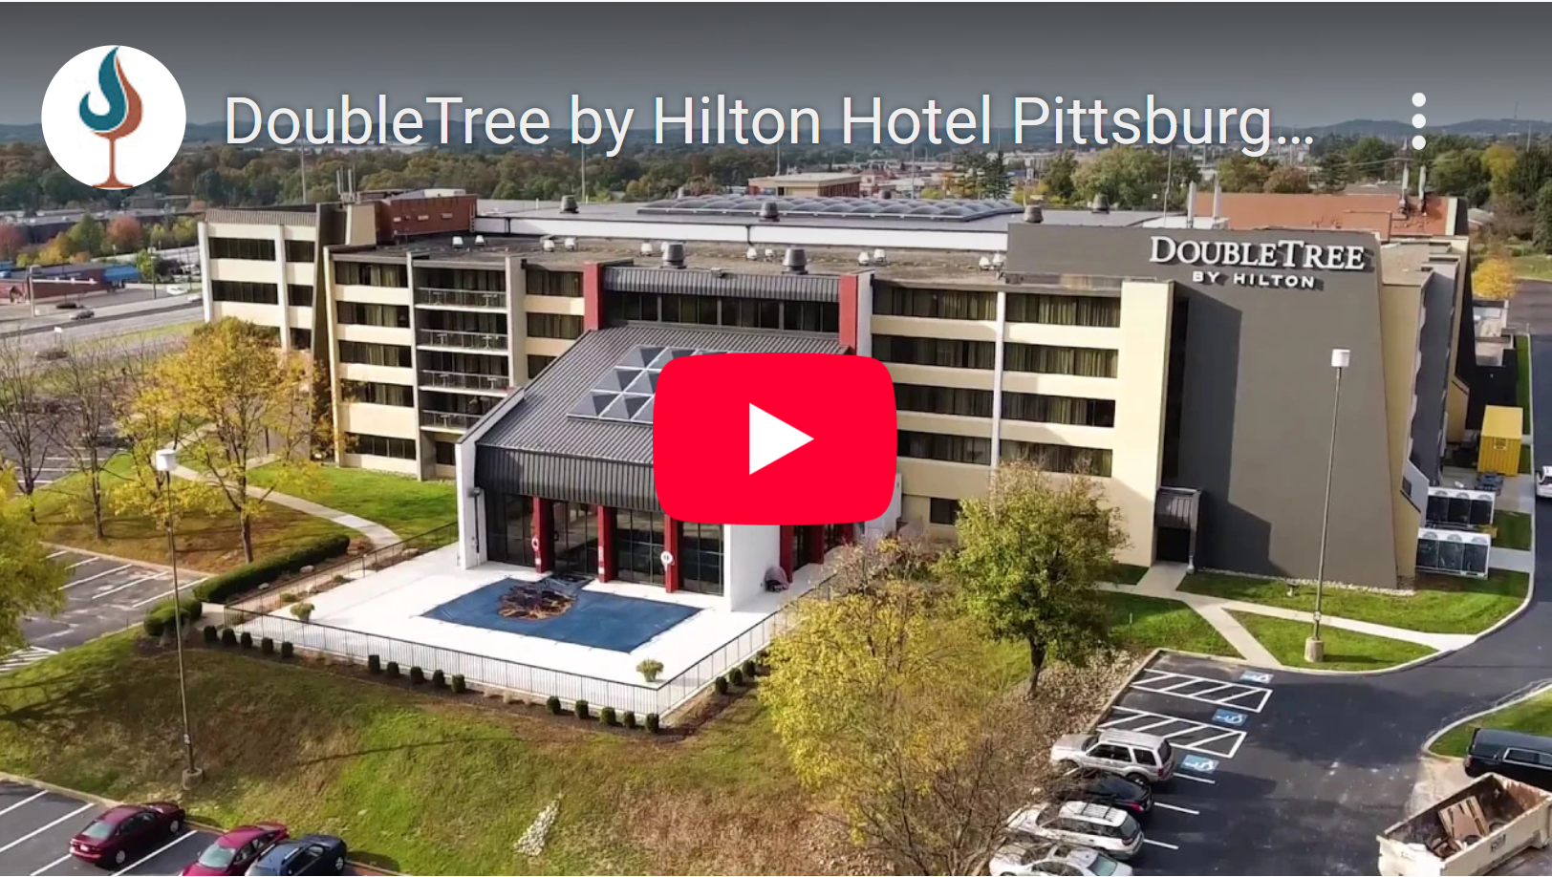
A block of rooms has been secured at the DoubleTree by Hilton Pittsburgh–Cranberry Hotel, located at the junction of I-79 (north–south) and the Pennsylvania Turnpike (I-76 east–west). This strategic location avoids most Pittsburgh traffic while remaining just 21 miles from Schenley Park via easily driven interstate highway.

The hotel offers an outstanding rate—under $200 per night including taxes—and features a large surface parking area capable of accommodating trailers. For those who prefer to detail their Jaguars on site, hoses with running water will be available. This will be the central hub for IJF event departures.​​​

Please note that at the top right of the Hotel Reservation page, there is an "Edit Stay" button to select the nights for which you wish to register. Without that, the DoubleTree Hotel reservation page just assumes you will stay from July 15 through July 20 under "Quick Book" on the blue bar.

Thursday, July 16th:

Scenic Drive, TSD Rally, and Garden Party
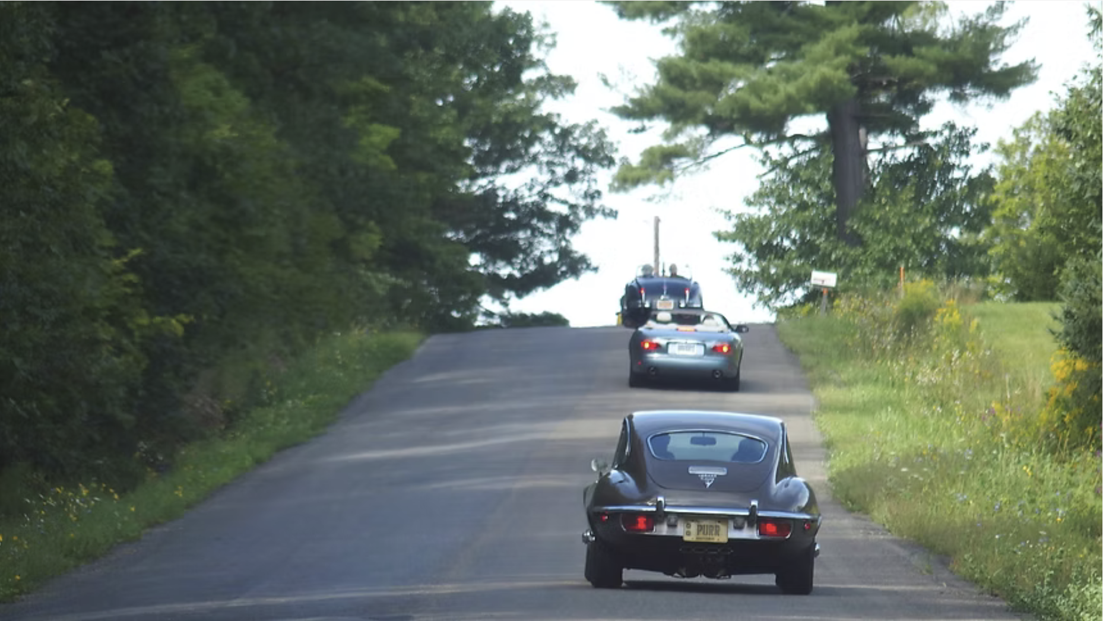
A morning TSD Rally and afternoon lunch are planned with the guidance of John Corey, JCNA Rally Committee Chair. Participants can either join in the time-and-distance rally or drive the same route as a scenic tour. Lunch reservations have been made at the end of the Rally/Scenic tour (at each person’s own expense) close by to the DoubleTree Pittsburgh-Cranberry Hotel. This event will end early enough in the day for attendees who choose to attend the Garden Party at Phipps to have time to clean up and travel to Phipps Conservatory in Schenley Park. $15 per car, prizes will be awarded for the Rally.
​​​​​​​​​​​​​​_________________

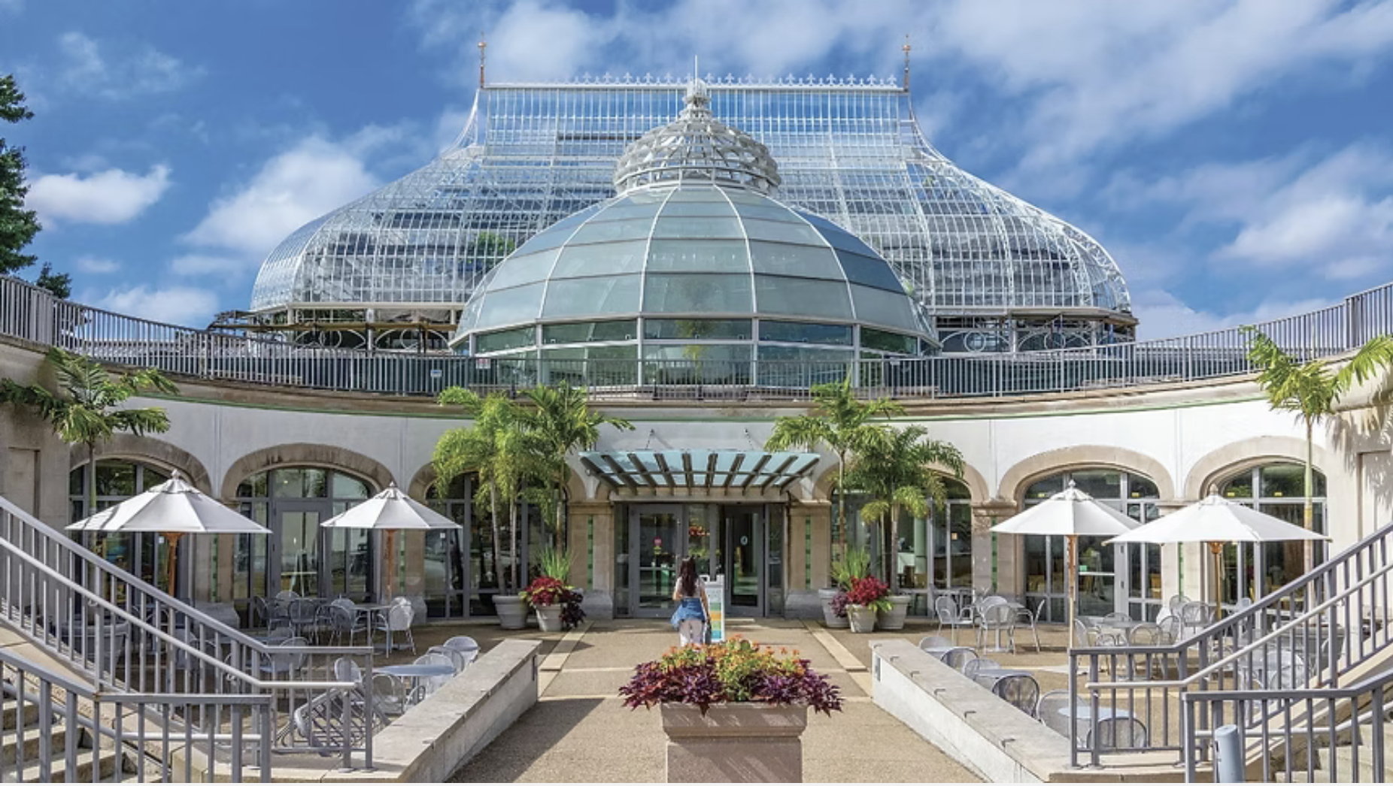
Thursday evening brings one of the PVGP’s most elegant traditions: the Garden Party at Phipps Conservatory. This Victorian-era landmark, filled with spectacular flora from around the globe, will host food and drink stations throughout the conservatory. Jaguars will be given pride of place on the lawn in front of Phipps until space is filled—a truly unforgettable setting. Details.

Friday, July 17th:

Slalom and a Night to Remember...

The International Jaguar Festival Dinner
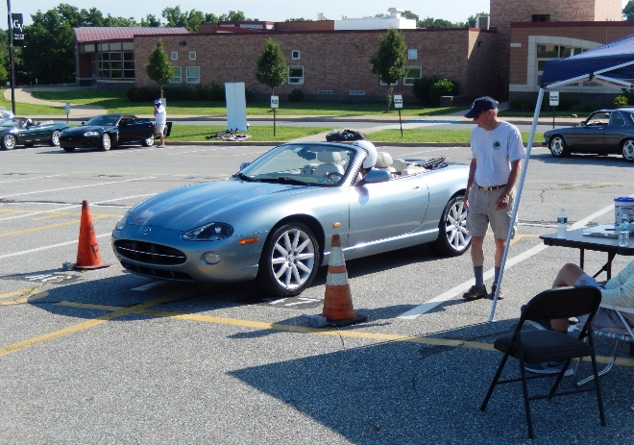
An IJF slalom is planned to be conducted at the Manheim-Butler Auto Auction, which is only 4 miles from the DoubleTree Hotel where IJF guests are staying.
This event will conclude early enough in the day for participants to clean up and travel to the Pittsburgh Golf Club in Schenley Park for the Friday evening IJF Dinner. $35 entry per car. Jaguars of all years are eligible. Prizes will be awarded. More details to follow in terms of what time of day it will commence once enough Registrations have been received to make it an official Slalom as well as the possibility that JCNA is going to hold a special meeting the afternoon of July 17 to address 2027 Concours and Judging matters.+
_________________
​​​​​​
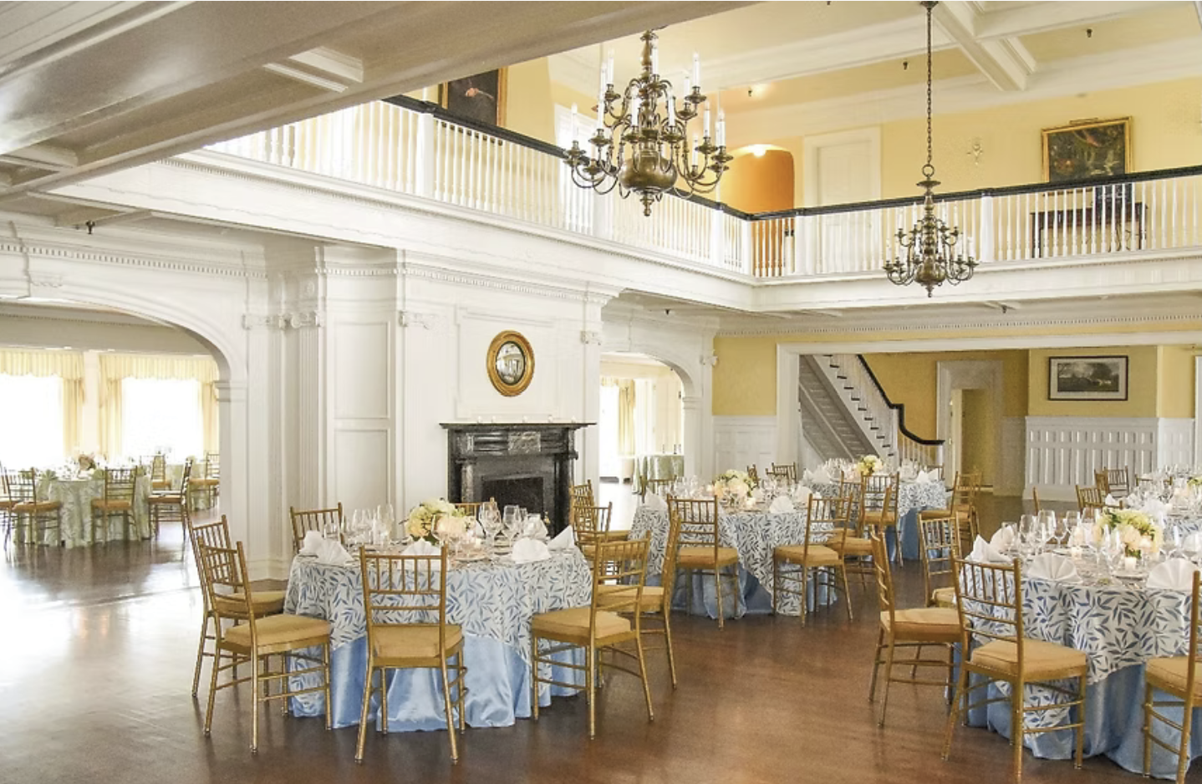
Friday evening is one of the crown jewels of the IJF: a Dinner Reception at the historic Pittsburgh Golf Club. Set in an elegant clubhouse, the evening will feature superb cuisine and a keynote address by Ian Callum. Parking will be on the adjacent golf course, which becomes the heart of the PVGP International Car Show the following day.

This is a once-in-a-lifetime opportunity to hear directly from, and interact personally with, one of the most influential automotive designers of our era in an intimate and refined setting.

Saturday, July 18th:
The Heart of the Festival
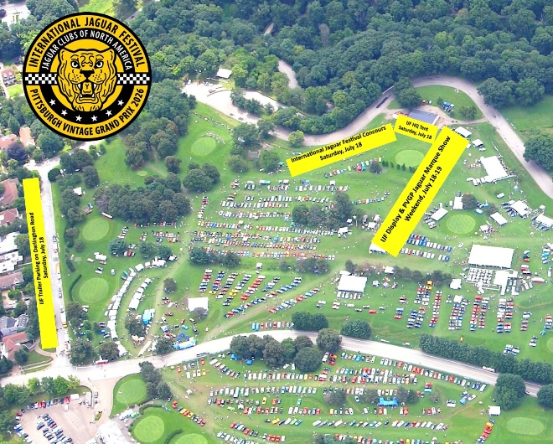
Saturday is where everything comes together.
​
More than 3,000 vehicles will fill the Bob O’Connor Golf Course for the PVGP International Car Show. Jaguars, as Marque of the Year, will be prominently featured as IJF Concours d’Elegance and Marque of the Year Display vehicles. Vintage race cars will thunder past throughout the day as Concours judging takes place, creating an atmosphere unlike any other concours in the world.
​
The IJF tent will serve as mission control—strategically located, well-appointed, and staffed throughout the day. Registrants may purchase a Saturday food package in advance, providing everything from morning coffee to cold drinks all day, plus breakfast and lunch options. Meals will include freshly grilled chicken and BBQ beef brisket, served on salads or brioche buns, along with appropriate side dishes.
​
Concours and other Display entrants are encouraged to arrive early—between 6:30 and 8:00 a.m.—to avoid congestion. Trailer parking will be available on a nearby street and overflow lot IF THOSE BRINGING TRAILERS PRE-REGISTER THEIR TRAILERS. Chief Judge Bryan Williams welcomes judges from across JCNA to participate. Due to anticipated demand, concours entries will be accepted on a first-come, first-served basis by class. Display entries will be closed at the beginning of July. Anyone wanting to trailer their Jaguar to the show needs to communicate pursuant to the information provided below.
​
Concours Awards will be presented Saturday afternoon at the IJF tent, with Ian Callum personally presenting the trophies. A photographer will ensure anyone wanting a photo with Ian can have one taken.
​
For those wishing to have a Jaguar autographed by Ian Callum—provided it is one of his designs— or some other item, bring your preferred marker and plan ahead. Ian will be available throughout much of Saturday when not performing Grand Marshal duties.

Registration Details
To get information about the IJF, please visit jaguarclubofpittsburgh.org and click on "International Jaguar Festival" at the top. Alternatively, use this direct link or put it in your Browser: https://www.jaguarclubofpittsburgh.org/ijf . At the bottom of the page, click on the “PVGP/IJF Information” green button (or go directly to https://pvgp.org/car-show-overview/jaguar2026/ ). After you play the video (ensure your speakers are turned on loud enough!), review those pages and to register you click on the blue Vivenu button that takes you to Registration and on-line payment.
Payment: All payments will be processed through the Vivenu website.
- Important: Ensure that all participants, whether for the Concours, Display vehicles, Rally, or Slalom, complete the necessary forms (available through links on Page 1 of the Vivenu website) and send them to the respective event chairs per the information on the forms and the website:
  - D. Bryan Williams (Concours dsw222h@aol.com
  - Shadrach Jones (Rally) shadrach.jones@yahoo.com
  - Craig Gestler (Slalom) craig.gestler@gmail.com
  - Jake Zoller (IJF Display vehicles) jdzoller55@gmail.com
Trailer Parking Information
Trailer parking is available at the DoubleTree Hotel. If you plan to bring a trailer, please complete and return the Trailer Information Form included in the registration forms for Concours, Display and Slalom events on page 1 of the VIvenu wesite. All trailer parking other than at the hotel needs to be pre-reserved and will only be confirmed after return of a completed trailer questionnaire. If you have any questions about this, contact Stu Benson at 412-491-1586 or stubenson3@gmail.com .

Sunday and Beyond
While the IJF officially concludes Saturday afternoon, registered Display and Concours vehicles are welcome to return to the golf course on Sunday as vintage racing continues. IJF registrants will receive wristbands granting access both days.

Sunday is an ideal time to explore the paddock areas and the start-finish line via PVGP shuttle buses. Food and beverage vendors will be plentiful, and attendees are also welcome to bring their own provisions. JCOP members can provide recommendations for excellent local food options for those visiting from out of town. There will be no IJF tent or food package on Sunday since the IJF concludes on Saturday and it is expected many guests from out of town will leave some time on Sunday to return home.

Registration and Information
As referenced above, all registration will be handled through PVGP. Access their dedicated Jaguar Marque of the Year and IJF portal at pvgp.org/car-show-overview/jaguar2026, where participants can reserve hotel rooms and select event options and pay for the same using a Vivenu third party, secure website. One should select all choices of activities desired before paying at the end and providing necessary contact information at the end; doing it this way by paying for all “menu selections” at one time will reduce the credit card fee being charged. If you are purchasing any event or package for someone other than yourself, please advise Stu Benson of their name via email (stubenson3@gmail.com ). Entrants in the Concours d’Elegance, Marque of the Year Display, Rally, and Slalom events must print and submit the appropriate hard copy forms directly to IJF Event Chairs as noted above.

Why You Need to Be Here
Ramsey Potts—founding partner of Broad Arrow Group and 2025 PVGP Grand Marshal—captured the essence of the event perfectly in his reflections last year. He spoke of obstacles transformed into opportunities, an unmatched gathering of collector cars, and, above all, the extraordinary volunteers who make the PVGP unlike anything else in the collector car world.
​
“I have no official data, however, my eyes were wide open and I saw collector cars in numbers I can’t ever remember seeing! You filled a golf course to capacity and hosted the most stupendous gathering of every possible kind of collector car! I heard from first time attendees and they were blown away by the volume, and I spoke to “regulars” who were equally gobsmacked at the quality! I will say it, and because of my role as a Broad Arrow Car Specialist, I can say it with some authority, the PVGP show field is without rival in its scope and volume! …….. No other event, no other place, and no other group of volunteers… simply nothing else of its kind exists…… You need to be here.”
​
In 2026, Jaguar takes center stage in this extraordinary setting.
​
If you love Jaguars, history, design, driving, and the fellowship of like-minded enthusiasts—there is no better place to be.
​
You really do need to be here. In Pittsburgh at the IJF from July 16-18, 2926. And think about coming early to enjoy other PVGP activities and events as well as staying on Sunday, July 19 for great wheel- to- wheel racing where it can be viewed up close.
​
For additional information, visit pvgp.org/car-show-overview/jaguar2026, or contact Stu Benson (412-491-1586) | mailto:stubenson3@gmail.com).
​
—By Stu Benson, Jaguar Club of Pittsburgh, Chairman of the JCOP PVGP IJF Committee

Be sure to enjoy the two videos posted at the beginning of this article by clicking on them to view the YouTube presentations. Make sure the volume in your speakers is turned on loud enough! They can also be viewed at
https://www.jaguarclubofpittsburgh.org/ijf by clicking this link or putting it into your browser.

